Cloud Architect, Cloud Network Engineer

Compute, Networking

**Lab Details**

1. AWS Auto Scaling will automatically scale resources as needed to align to your selected scaling strategy. This lab walks you through using Auto Scaling to automatically launch or terminate EC2 instances based on user-defined policies, schedules and health checks.
2. Duration: **55 minutes**
3. AWS Region: **US East (N. Virginia) us-east-1**

**Introduction**

What is Amazon EC2 Auto Scaling

* Amazon EC2 auto scaling is designed as a fully managed service that controls the number of running instances, in case your workload is higher, it will match by launching more instances instantaneously.
* Unlike load balancer, you don’t provision EC2 Instances in advance and register as a target but you define the whole configuration in the Launch template which will scale out or scale in based on the traffic.
* In auto-scaling, you also define what will be minimum capacity, desired capacity, and maximum capacity. Autoscaling makes sure that the number of instances specified in desired capacity is always running when traffic is normal, it will scale in when traffic is lowest and scale-out when running there is a spike.
* While creating auto-scaling, it requires a Launch template where you specify which AMI to choose, what will be instance type, security group associated, and all other options required to launch EC2 Instance including key pair.

What is the difference between Launch Templates (LTs) and Launch Configuration (LCs)

* AWS Recommends using Launch Templates (LTs) over Launch Configurations (LCs) because LTs provide the latest features.
* Launch configurations are immutable in nature, once you create, you can't edit them so replacement is only the option. Where Launch template provides versioning, at a time you can create multiple versions and make one of them as default for use.
* Using Launch templates, you can use the T2 Unlimited burst feature.
* Launch templates allow provisioning both On-demand and Spot Instances.
* Launch templates are compatible to use with AWS Management Console, AWS SDK, and AWS CLI.

**Architecture Diagram**

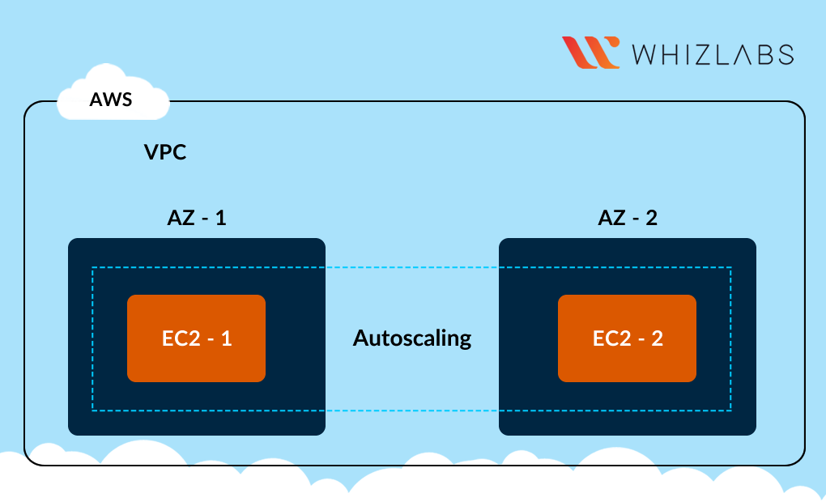

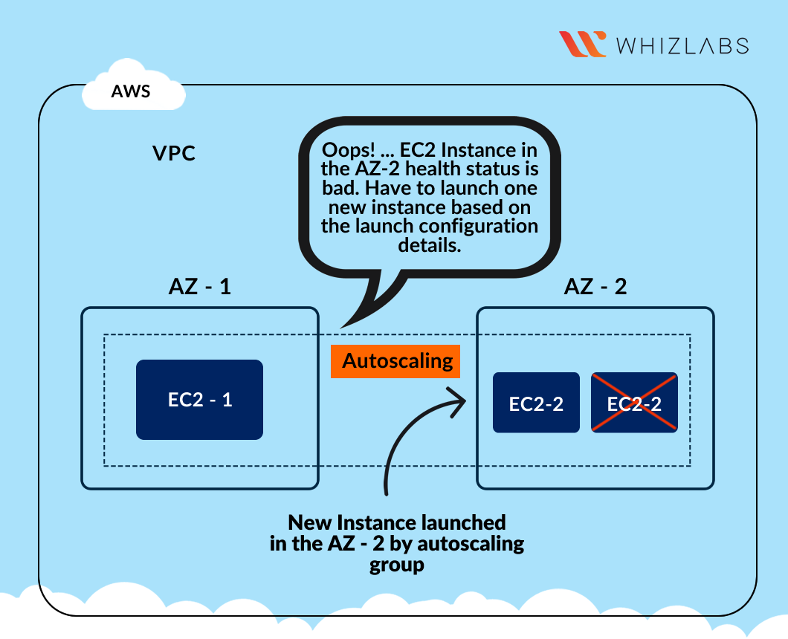

**Task Details**

1. Sign in to AWS Management Console.
2. Creating Launch Template
3. Create an Auto Scaling group
4. Test the Auto Scaling Group.
5. Validation of the lab

**Launching Lab Environment**

1. To launch the lab environment, Click on the  button.
2. Please wait until the cloud environment is provisioned. It will take less than a minute to provision.
3. Once the Lab is started, you will be provided with **IAM user name**, **Password**, **Access** **Key**, and **Secret** **Access** **Key**.

**Note** : You can only start one lab at any given time